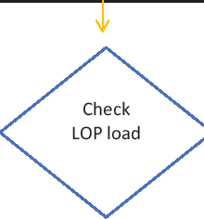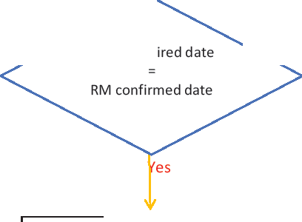

Select LOP of particular

order

ORDER MANAGEMENT - FLOW CHART

Order registration **Unidesimreports.exe**

Go to PPC sale date page

Sort NO· New order received status

Select order

PLANNING ,j,

}o IPress Upload LOP in EMR

Enter First production delivery date

,j,

Press Populate date

t

Check pla nned RM & CAD date

l

Press generate bag & Send email

,j,

Go to diamond/CS/finding/Cad

confirmation pa e

t

Select order

,j,

If multiple order use Export option to **UniERP login**

download

,j,

RM/CAD HOD Select vendor

,j,

Enter Dia mend/cs/finding/cad confirmation date

t

If multiple order use Import option to Upload

,j,

Press confirm button

t

Go to PPC sales date page

,j,

Sort confirmation date status NO - Pendingl Yes -ionfimed

Request to respective

Select order deprtment to confirm the

date

t

PLANNING

No-

Enter Final production delivery date Enter fina I production

delivery date based on RM

First production de live date confirmed date

,j,

Press populate dates & update in

EMR

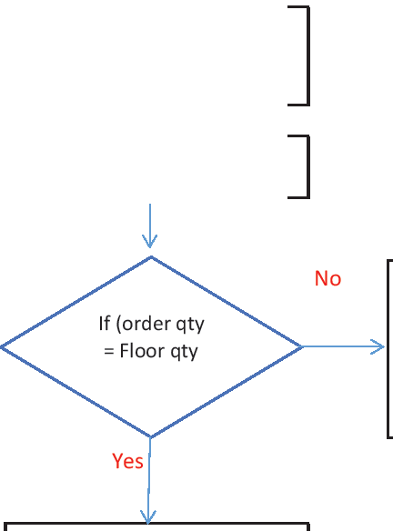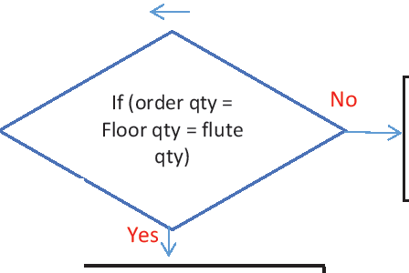

Pending on production

HOD

Take action to match

quantity

ORDER AMENDMENT

Order amendent register **Unidesignreports.exe**

Go to order amendment page

Sort amendment pending to acknowledge

ISelect order

If multiple order use Export & Import option to

acknow led e

Acknow ledge the amendment

Sort amendment pending to

send

ISelect order

If multiple order use Export & Import option to

acknowled e

IPress send button

Go to order amendment page

Sort order pending to acknowled e

If multiple order use Export & Import option to

acknow led e

PRODUCTIONIRM

IAcknow ledge the order

Sort order pending to action

Take action against

amendment

Go to order amendment page

Sort amendment pending

status

ISe lect order

If multiple order use Export/Import option to acknow led e

IPress amendment button

**PRODUCTION REVISED DATE - FLOW CHART**

Go to revised production date

# page

Sort order to revise date

# Multiple

Export file

PRODUCTION MANAGER

# Sing e

Enter the reason to revise

Enter revised date

Press confirm button

Go to order approve page

Sort order for approval

# pending

If multiple order use Export

option to download

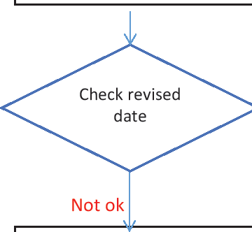

Enter remarks

# Rejected

If multiple order use Import option to Upload

Go to revised production date

# page

Enter the reason to revise

Enter revised date

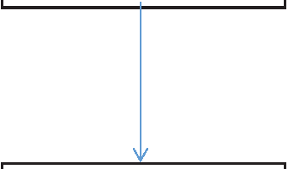

# 1E----1lmport file

Ok

# Approved

UniERP login

Sort Revised order status:

# rejected by CMC

ISelect order

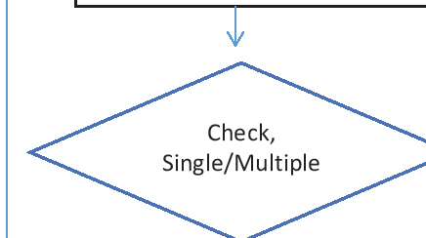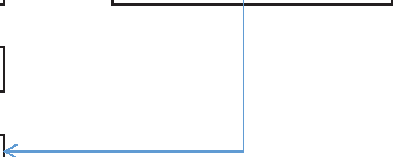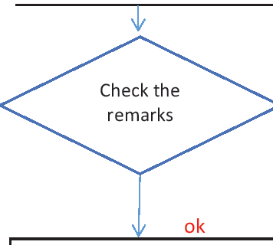

PRODUCTION

# Select Yes in Change date

IEnter the reason to revise

J

Enter revised date

Go to order approve page

Sort order for approval

# pending

Icheck revised date

IApproved

Not ok

1

# Discuss with CMC &

mutually get agree on dates

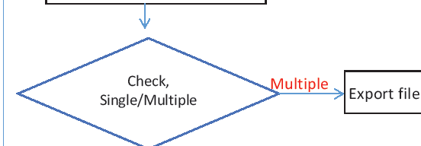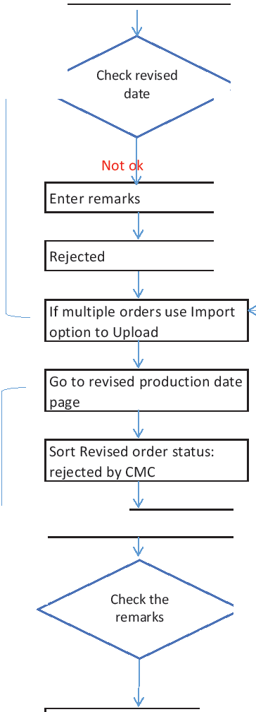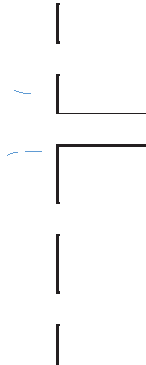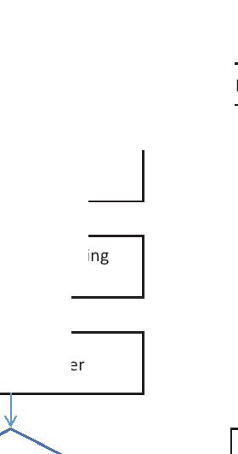

No changes in production

date

RM REVISED DATE - FLOW CHART

IGo to revised RM date page

Sort order to revise date

*l*

.!!M Si gle Enter the reason to revise

Enter the reason to revise Enter revised date

Enter revised date

Press confirm button l 1mport file

Go to revised production date page

Sort acknowledge pending order

Acknowledge the order

**PLANNING**

vf

Enter revised date

IPress confirm button

J

Go to order approve page

Sort order for approval

pending

**UniERP login**

If multiple order use Export option to download

CMC

Ok

Approved

J

ISelect order

Not ok I

Ok

Discuss with CMC &

Select Yes in Change date production mutually get

a ree on dates

Enter the reason to revise

Enter revised date

Go to order approve page

Sort order for approval

pendin

Check revised date

IApproved